Module 5 — Tax on Agricultural Income
The government’s official reason is true — but the real reason is something else. And once we understand it, we realise why keeping accounts is a farmer’s greatest protection.

1. Learning Objectives
- Understand the government’s official reason why agricultural income is not taxable in India.
- See, through a real example, how much a farmer’s true daily profit is.
- Understand why keeping farm accounts is necessary even though income is tax-exempt.

2. Introduction
In India, farm income is not treated as taxable income — agricultural income is tax-exempt. The official reason for this is not hard to understand, but the real reason behind it is deeper and thought-provoking. Once this is understood, we realise why, whether or not tax applies, keeping accounts is a farmer’s greatest protection.

5.1 Why is farm income not taxable? The government’s official reason
In any business, tax is levied on the actual net profit — not on total turnover or income. For example, if an agricultural input shop has an annual turnover of ₹15 lakh and expenses of ₹10 lakh, the net profit is ₹5 lakh — tax is levied on these ₹5 lakh, not on the ₹15 lakh turnover. If farm income were ever taxed, the same principle would apply to it too.
In India, farm income is not treated as taxable income, and the official reason for this is that the income from farming is so low that taxing it is pointless. The statistics also show the same — according to the last officially published figures, the average monthly income of a farmer family in India was only ₹10,220 (2019), which was only ₹6,430 in 2013.
Table 5.1 — Average monthly income of a farmer family
Year | Average monthly income (₹)
2013 | 6,430
2019 | 10,220

At this income level, most farmer families would remain well below the taxable income limit — which is why this official explanation of the government seems logical.
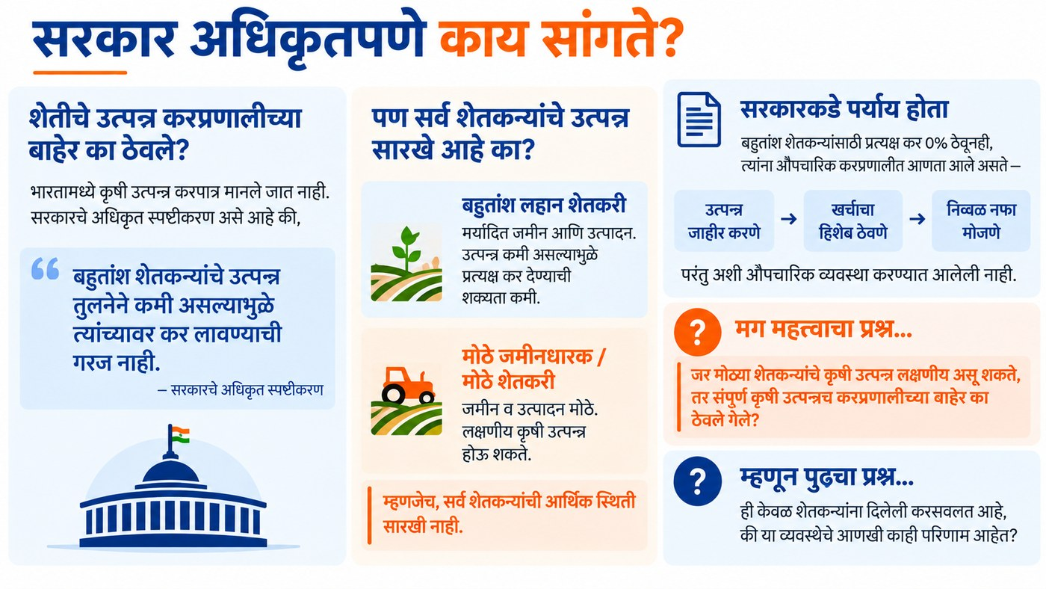
Figure 5.1 — What the government officially says

5.2 What could be the real reason? A real example
But a more important question remains — why were farmers kept entirely outside the ambit of tax? The government could have formally brought agricultural income into the tax system — even if the actual tax rate would have remained 0% for most farmers — only so that they too would have been required to file returns and keep a proper account of costs and profit. This was not done.
The reason could be this — if farmers had had to pay income tax, they would first have had to keep an account of their costs and work out their net profit. And the day farmers themselves began working out this figure every season, they would have found out something that perhaps the system does not want revealed on a wide scale: that their true net profit, calculated per day, is often not even as much as what they pay their own labourers.
Let us look at the example of a soybean-growing farmer from Ahilyanagar district in Maharashtra — total cost ₹26,800 on one acre of soybean, income ₹30,000, net profit ₹3,200 per acre, crop duration 90 days.
Table 5.2 — A farmer’s own daily earning versus a labourer’s wage
Who | Daily earning (₹)
Hired farm labourer | ~350
Farmer’s own net profit (soybean, kharif, per day) | 35.56

The farmer’s own daily earning works out to roughly one-tenth of the wage paid to the labourer working on his own farm. This is the figure that perhaps is not meant to be worked out or understood on a wide scale. As long as agricultural income is outside the tax system, there is no formal need for any farmer to measure his own cost and income every season and face this figure.
Unsettling arithmetic
Daily net profit = ₹3,200 ÷ 90 days = ₹35.56 per day
The wage this same farmer paid to his labourers: about ₹350 per day
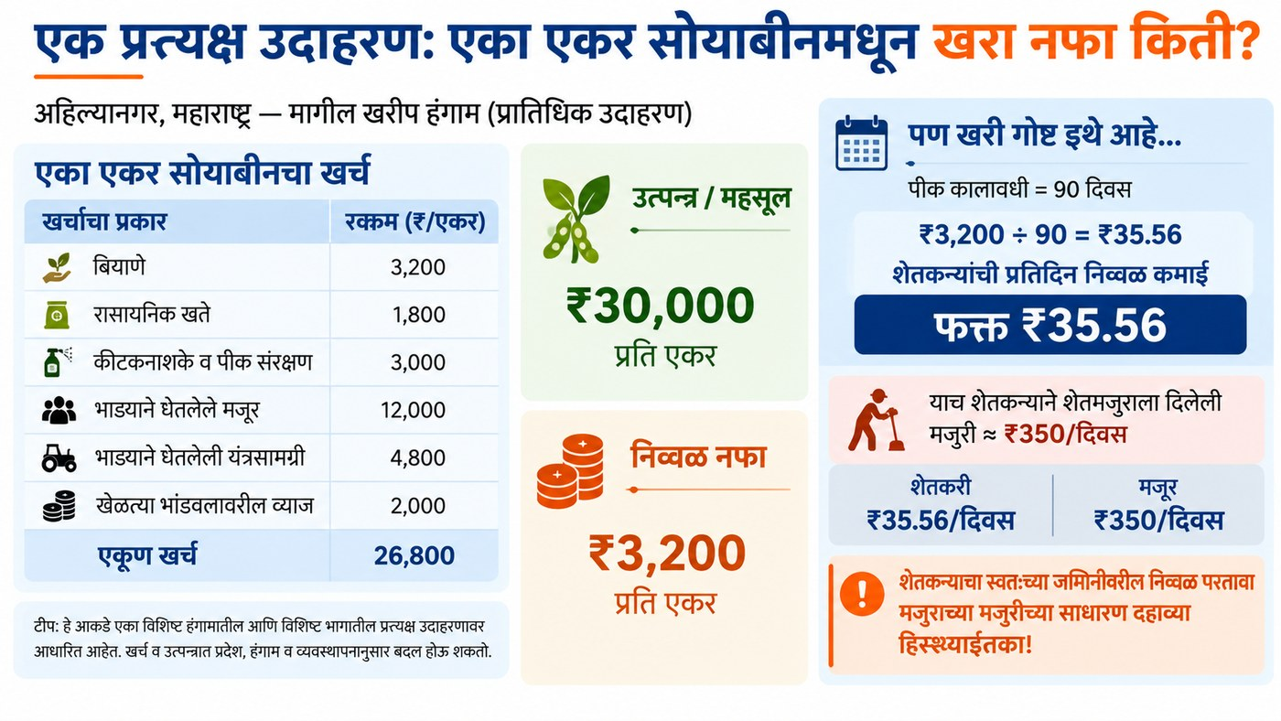
Figure 5.2 — A real example: what is the true profit from one acre of soybean?

5.3 The real importance of keeping accounts
Whether or not farm income comes into the tax system, the real problem remains the same: without keeping accounts, a farmer never truly knows how much he actually earns per day, per acre or per season — until he works out this account himself.
That is why keeping an account of farm production cost is necessary — not for tax, but because this is the only way through which a farmer can see his true return, put his case in the MSP discussion, and decide whether a crop is worth growing again. Farm income being tax-free is not merely a relief — it also removes the only formal method that could bring this unsettling figure before him every year.
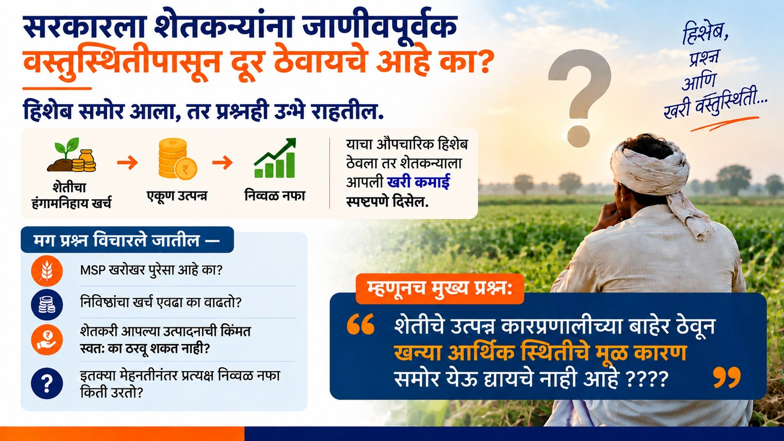
Figure 5.3 — Keeping accounts is the farmer’s true protection
ℹ Note
This section is given for general information and awareness about tax matters on agricultural income. It is not tax or legal advice — everyone’s situation is different, so farmers or organisations should consult a qualified tax expert according to their situation.

Key Concepts
- Basic rule of tax: tax is levied on profit, not on turnover.
- Tax-exempt agricultural income: in India, farm income is excluded from income tax.
- Daily net profit: the figure obtained by dividing the total profit of the season by the number of days of the season.

Key Takeaways
- The official reason for farm income being tax-exempt is that most farmers’ income is below the taxable limit.
- Without keeping accounts, a farmer never knows his own true daily profit.
- In some examples, a farmer’s own daily profit can be even less than the wage he paid to a labourer.
- Whether or not tax applies, keeping your own accounts is the tool for demanding a fair price and making informed decisions.

Review Questions
- What is the government’s official reason for farm income not being taxable in India?
- What was the daily net profit of the farmer in the soybean example, and how did it differ from the labourer’s wage?
- Why is keeping farm accounts important even when no tax applies?

Module Summary
In India, agricultural income is tax-exempt because most farmers’ income is far below the taxable limit. But because of this, farmers are not required to keep a formal account of their costs and profit, and so their true daily profit — which is sometimes even less than a labourer’s wage — never comes to light. That is why, whether or not tax applies, keeping accounts is a farmer’s own protection and a tool for demanding a fair price.

